James Weech Carden and family – the missing years and the First World War

James Weech Carden was born on 27th September 1862 in Old Road, Chatham, son of John and Mary Carden. Mary’s maiden name was Nash. (Hold on to that – it becomes significant later…).
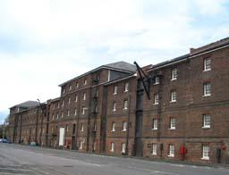
Chatham Dockyard, where James’s father was Foreman of Sweeps
John Carden’s job was noted at the time as ‘Warehouseman to Grocer’. Later, in 1887, he was ‘Foreman of Sweeps at Chatham Dockyard.’
James was the fourth of six children, the family living in Rochester in 1871. At the age of 18 (the 1881 census) he was a telegraph clerk in Dover, boarding with the Thorp family, whose son was a colleague.
He married Agnes Hills in 1887 (his name shown as James Winch Carden). She was four years his junior and from Colchester.
In 1891, at the age of 28, they were living in Maidstone on Sandling Road with, at that stage, three children: Albert William Weech Carden born 1888, James Edward Carden in 1889, & William John Carden in 1891.
James at this time seems to have been a ‘hairdresser’, apparently different to a barber who would cut hair. A hairdresser at the time was probably a wig-maker, and self-employed.
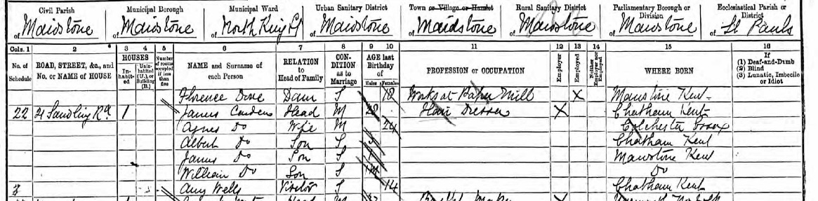
1891 Census
They had more children, Charles Frederick in December 1893, the first to be born in Camberwell in London, and Ernest in 1895, though baby Ernest died that same year. Percival Stewart was born in 1896 and Florence in 1898.
My grandfather, Robert French Hector Carden, was also born in 1900 in Camberwell. Note name Carden, not Nash. Because by 1901, they were all living under James’s mother’s maiden name, Nash. It seems likely that about this time, they had a family photo taken:
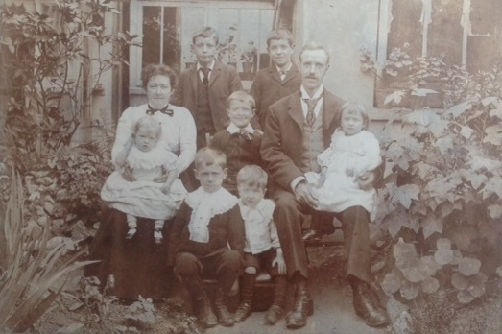
James and Agnes Carden and family – seven children, with one having died as a baby.
They registered the whole family for the 1901 census as Nash, and the three children born after 1901 were formally registered as Nash: Stanley Herbert Nash in 1902, Gertrude Ivy Nash in 1904, and George Victor Nash in 1906.
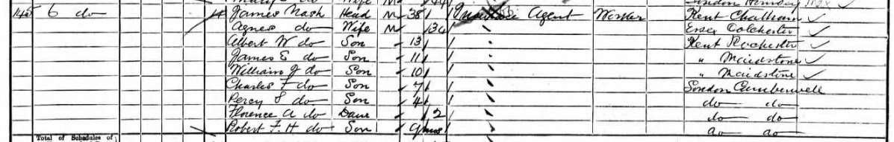
1901 Census

They lived in 1901 at Stobart Mansions, Camberwell, just down from Camberwell Public Baths. James is listed as an Insurance Agent in the 1901 census.
By the birth of James and Agnes’s twelfth child, Sydney Leslie, in 1909 (when Agnes would have been about 43), they were living back in Maidstone, and Sydney was registered as a Carden.
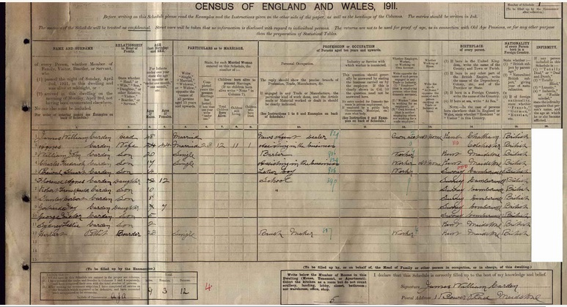
1911 Census
James’s middle name was now shown as William, and he was a ‘News Agent Dealer’. I think the address might read 1, Bower Place, Maidstone, a five-bedroom house. The oldest children, Albert and James has moved out by now.
James and Agnes would seem to have been enthusiasts for Britain’s Empire. Robert French Hector Carden was named after famous British military figures in the Boer War. Most of their children old enough to join the forces had done so before or during the First World War.
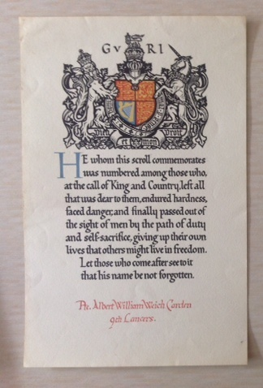
WW1 scroll commemorating Albert William Weech Carden
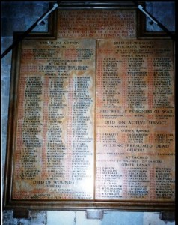
9th Royal Lancers Memorial at Canterbury Cathedral, including Albert W W Carden, courtesy of roll-of-honour website
The oldest, Albert William Weech Carden joined the 9th Queens Royal Lancers, part of the Household Cavalry.
The 9th Lancers were the last cavalry to charge lance-on-lance against enemy cavalry in the first weeks of the First World War as part of the Expeditionary Force.
Albert was killed a few weeks later, on 29th September 1914, in France.
He is buried in a Longueval military cemetery in northern France, and you can see his name listed as Killed in Action on the 9th Lancers memorial in Canterbury Cathedral. He was 26.
James and Agnes received a commemoration scroll for the death of their oldest son, which I have the original of here.
Their next four surviving children also joined the forces. James joined the Navy, Charles and William the army.
Percy joined the Royal Army Medical Corps before the war but transferred to the Royal Engineers after the war started. He was also killed in action, in 1917, and he is also buried in northern France at Tincourt British Cemetry.
He was a tunneller, tunnelling underneath German lines. He was aged 21 when he was killed.
James and Agnes also received a commemoration scroll for Percy, and would have read in the Kent Messenger on 9th June 1917:
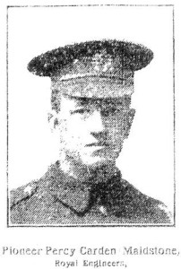
Percy Carden
Killed 1917
Pioneer, R.E. Pioneer Percy Carden (Maidstone)
Royal Engineers
WHO HAS DIED OF WOUNDS
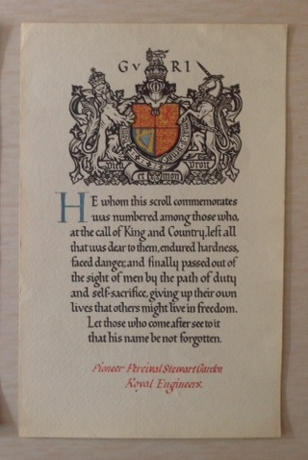
Pioneer Percy Carden, R.E., age 20, son of Mrs. Carden, I Bower Place, Maidstone, was taken to a casualty clearing station, France, on the morning of May 25th, suffering from gun shot wound in the chest, and died the same evening. He joined the R.A.M.C. Territorials, but after the war broke out transferred to the Royal Engineers, and was attached to the Tunnelling Corps. He had been in France one year and eight months – at the front line the whole time. His oldest brother, in the 9th Lancers, was killed September 29th, 1914, and there are three brothers still surviving: James Edward, Leading Seaman Gunlayer, on H.M.S. Victory; Charles A.O.C., in Egypt, and William, A.S.C., in France.
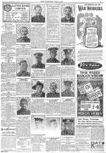
The Kent Messenger showing those Killed in Action, 9th June 1917

So by the end of the First World War, of James and Agnes’s twelve children, two had died as a babies, and two had been killed in action.
In 1921, on Charles’s marriage certificate, James was shown as James William, and was a Hairdresser. In 1928, on George’s marriage certificate, James was also shown as James William, and was a Newsagent.
Agnes Carden (née Hills, and sometimes Nash) died in March 1937.
James Weech Carden (sometimes Winch, sometimes William, sometimes Nash) died in September 1940. Both in Maidstone
.

